NHS Service re-design via Quality Improvement (QI)
Introduction
The NHS Long Term Plan (LTP) ², published in January 2019, makes many references to the requirement for service re-design. The LTP suggests that Service re-design will be achieved through the well established NHS QI methodology (p111).
The NHS Trusts, via guidance from NHS Improvements through their QI initiative, are geared up to undertake Service outcome improvement. This is not the same as Service re-design. They have designed a 'Model for Improvement'³ based on the PDSA cycle. This is not that same as the PDCA cycle used by the rest of the UK. See Figure 1, PDSA vs PDCA. QI (quality improvement)⁴ is similar to what engineers refer to as CI (continuous improvement)⁵. The difference though is not only in the name. The key difference is in the word 'quality'. The NHS's definition is the same as what engineers call product or service specification or rather User Requirements. In engineering terminology this has little to do with what engineers mean by the word quality. So the NHS improvement strategy is to improve outcome standards, where the engineer's improvement strategy is to improve process, thereby meeting the pre determined product or service outcome specification.
This situation is further complicated in that engineers have control over their process inputs whereas the NHS have little control over their process inputs, i.e. patients. This must be a key consideration when designing NHS services particularly in terms of cycle time.
Context
This paper follows on from the theme of the previous two IET Healthcare papers, Design and Evidence - Does involving users slow down or speed up innovation?⁶ and Healthcare Commissioning - time for a more business-like approach?⁷ The first paper looks at service specification taking into account user needs and an understanding of the possible technical solutions available. The second paper looks at current inherent service variable quality and experience by patients and offers a three stage solution to standard quality and experience. Note: This is, it is assumed, the engineering definition of quality.
As the title indicates, this paper will discuss the differences and application of two very different Service improvement techniques, both very familiar to engineers. These are Service re-design and quality improvement. The first two papers in this IET Healthcare series discussed Service design. Service re-design follows the same process so this paper, after discussing the difference between Service re-design and Service improvement, will concentrate on Service re-design. For Service re-design a new Service specification and Service delivery system are required, for Service improvement a suitable service specification already exists and only small changes to the existing specification and Service delivery system are considered, i.e. step changes.
The Task
For Service re-design, if unbroken Service is required as is usually the case, the newly designed Service will be required to run in parallel to the existing Service until the new Service has been commissioned and trialed. For Service improvement, small adjustments to the existing Service can be made, using the PDCA cycle⁸ and various other improvement techniques, whilst the service continues to operate with some minor disruption.
So far four methodologies have been briefly discussed. These are:
- Service design,
- Service re-design,
- Quality improvement (QI), and
- Continuous improvement (CI).
The service specification or requirements specification has also been mentioned.
Service design and service re-design follow the same methodology.
NICE publish a general service specification 'Patient experience in adult NHS services'⁹. This document is referred to as a Quality standard. Published: 17 February 2012, updated July 2019 www.nice.org.uk/guidance/qs15. CCGs (Clinical Commissioning Groups) will publish specific and detailed specifications prior to a new service being commissioned, and, it is assumed, prior to a service re-design. It's not clear how this process works in practice. Ref?
A key theme of the NHS Ten Year Plan is the application of new technologies particularly digital technology. The application of these new technologies, in many cases, will require service re-design as has been identified in the Plan. Because of the complexity of the new technologies there will be a requirement for an engineering input into the re-design of these NHS Services.
Service design/re-design
Four key considerations of service design are Technology, Facilities, Equipment and Processes. The design must ensure that these four elements work together to enable the new or re-designed service to meet the requirements of the service specification. The design team will require more than experience of working in the NHS and a PRINCE2¹⁰ qualification.
Design methodologies like the Double Diamond¹¹ design process are commonplace. A more suitable methodology for the complex services operated in the NHS is Quality Function Deployment (QFD)¹².
QI as a Service re-design methodology
Quality Improvement (QI) and Continuous Improvement (CI) have the same end objective but are very different methodologies. The end objective is clearly an improvement. QI seeks to improve service outcome. CI seeks to improve service delivery processes. In order to apply the CI methodology a pre-requisite is that work processes are defined and are stable (in control). This is called adopting the Process Approach¹³. Service delivery processes are monitored and a range of investigative and improvement tools¹⁴ are applied to identify an improvement. Once proven the process documentation, often referred to as 'standard work', is updated and the new process procedures are clear to all operatives.
In the QI methodology service outcomes are measured. An investigation attempts to identify which processes influence the outcome that is to be improved. Because the processes identified are neither clearly defined nor stable the investigators have to first work out how the process is delivered by interrogating the operators of that process. Improvements to the process are identified, using the same set of tools that are used in CI, but as the process is not adequately documented the improvements are often only implemented via a report or memo. This is not a sustainable solution. The QI methodology will not result in the Service re-design requirements of the LTP.
Some thoughts on processes
An interesting paper by David A. Garvin titled -'The Processes of Organization and Management'¹⁵ where he links work processes with the design activity and work management. A couple of sections are reproduced here but they are best read within the context of the whole paper.
On the Service design methodology and the Process Approach:
"Approaches to organization design must change as well. Most texts on the subject focus on tasks and structures, with detailed discussions of roles, positions, levels, and reporting relationships.⁶⁵ They say relatively little about processes or about how the work actually gets done. The implicit argument seems to be that organization design is largely a matter of architecture: drawing the right boxes and connecting them appropriately. A process perspective suggests that far more attention should be paid to organizational functioning, and that design efforts should begin by attending to processes and only later should shift to the structures needed to accommodate them".
and
On Service management and job descriptions:
"For this reason, the approach is unusually helpful in addressing implementation problems. Managers can articulate the required steps in a process, as well as improvements. By contrast, traditional lists of roles and responsibilities leave the associated activities unspecified or undefined. Job descriptions framed in process terms should therefore make it easier for untrained individuals to step into new jobs and acquire necessary skills.⁹² Managers should be able to focus their questioning of peers and subordinates on issues more directly related to the organization’s operation.⁹³ And a sensitivity to processes should give managers clearer guidelines about how and when to intervene effectively in others’ work".⁹⁴
Note: References in these sections are from the original paper.
These are very sensible suggestions and are worth consideration when planning Service re-design.
Summary
Four Service change methodologies and design specifications have been discussed. Service design and Service re-design follow the same methodology. Each requires a Service specification, usually in terms of outcomes, prior to any design activity beginning. Also discussed was the difference between Quality Improvement (QI) and Continuous Improvement (CI) methodologies. Finally the value of an organization taking a Process Approach and mentioned 'standard work'¹⁶ was discussed. These are two methodologies that are worth any organization adopting. Linking a group of processes to the NHS 'Model Hospital'¹⁷ measures would enhance the value of the Model Hospital output reports. It would really close the feedback loop.
Putting Service design/re-design and quality improvement in their rightful places
This is best illustrated using Juran's trilogy of Quality Planning (QP), Quality Control (QC) and Quality Improvement (QI)¹⁸(p2.5). Here Juran refers his definition of quality i.e. Big Q (p2.3) and not the NHS's definition¹⁹ which Juran calls little q (p2.3).
See Figure 2, The three universal processes of managing for quality (p2.6) and Figure 3, The Juran trilogy diagram (p2.7). It is clear from these two Figures that Service design is not the same as quality improvement. Again Juran's definition of quality is used.
It is very important to distinguish between Service improvement and Service design. Unfortunately a new initiative from the Royal Academy of Engineering does not do this. The 'Engineering Better Care'²⁰ toolkit and guide²¹ is a fine example of this. The practical application of the guide and toolkit will be very confusing. It describes the toolkit as a 'Healthcare Design Toolkit' but most of the text relates to Service improvement. The Service design, or Service re-design process, is a very different process to Service improvement and requires a different set of tools.
Conclusions
Service improvement methodologies (QI) in the NHS are regarded as being suitable for Service design and re-design activity; they are not.
Recommendations
1 That the QFD methodology is considered for Service design and re-design.
2 That Continuous Improvement (CI) methodology is considered for process improvement in the NHS.
3 That a Process Approach is considered for NHS Service management.
4 That where relevant Standard Work should be considered for NHS Service delivery processes.

And finally regarding NHS Service re-design via NHS Quality Improvement (QI):
NHS Service re-design | NHS Quality improvement (QI)
New Service specification required, co-designed with Customers/Patients | Uses existing Service specification - if available
Often required due to the application of new technologies | Undertaken by trained workforce with facilitator
Professional design team required | Co-production with patients encouraged
Major change | Step change
Engineering input required | PDSA methodology
QFD methodology¹² (Systems Engineering) | QSIR methodology²²
Process Approach¹³ (Visualization) | Model for Improvement³
Continuous Improvement (CI) | RPIW methodology²³
Standard Work¹⁶ | 366 improvement resources¹⁴
Scalable and Spread | No links to 'Model Hospital' measures¹⁷

References:
1 This AI Life, IET Healthcare, https://www.theiet.org/media/4022/this-ai-life.pdf
2 The NHS Long Term Plan, Published January 2019, https://www.longtermplan.nhs.uk/wp-content/uploads/2019/08/nhs-long-term-plan-version-1.2.pdf
3 NHS Model for Improvement https://improvement.nhs.uk/resources/pdsa-cycles/
4 NHS Quality Improvement (QI) http://www.wessexdeanery.nhs.uk/quality_improvement/what_is_quality_improvement.aspx
5 Continuous Improvement (CI) https://en.wikipedia.org/wiki/Continual_improvement_process
6 Design and Evidence - Does involving users slow down or speed up innovation? https://www.theiet.org/impact-society/factfiles/healthcare-factfiles/design-and-evidence/
7 Healthcare Commissioning - time for a more business-like approach? https://www.theiet.org/impact-society/factfiles/healthcare-factfiles/commissioning/
8 PDCA, Plan-do-check-act cycle, https://en.wikipedia.org/wiki/PDCA
9 Patient experience in adult NHS services, Published: 17 February 2012, updated July 2019, www.nice.org.uk/guidance/qs15
10 PRINCE2 (PRojects IN Controlled Environments),
https://en.wikipedia.org/wiki/PRINCE2
11 Double Diamond design process, https://www.designcouncil.org.uk/news-opinion/what-framework-innovation-design-councils-evolved-double-diamond
12 Quality Function Deployment (QFD), The QFD Handbook,1998, Published by John Wiley & Sons, ISBN 0-471-17381-9
13 Process Approach, ISO 9008, ISO 9000 Introduction and Support Package: Guidance on the Concept and Use of the Process Approach for management systems, ISO/TC 176/SC 2?N 544R3, 2008
14 Improvement Tools, https://improvement.nhs.uk/resources/quality-service-improvement-and-redesign-qsir-tools-type-approach/
15 'The Processes of Organization and Management', Author: David A. Garvin, MIT Sloan Management Review 39, no. 4 (summer 1998)
https://sloanreview.mit.edu/article/the-processes-of-organization-and-management/
16 Standard Work, https://www.virginiamasoninstitute.org/2015/05/how-does-standard-work-lead-to-better-patient-safety/
17 NHS Model Hospital, https://improvement.nhs.uk/resources/model-hospital/
18 Juran's Quality Handbook, Fifth Edition, 2000, ISBN 0-07-116539-8
19 The NHS definition of quality, https://www.england.nhs.uk/wp-content/uploads/2016/12/nqb-shared-commitment-frmwrk.pdf
20 Engineering Better Care, a systems approach to health and care design and continuous improvement. Royal Academy of Engineering, London, UK, 2017, http://reports.raeng.org.uk/engineering-better-care/cover/
21 Healthcare Design Toolkit, Royal Academy of Engineering, London, UK, 2019, https://www-edc.eng.cam.ac.uk/downloads/improvement.pdf
22 Quality, service improvement and redesign (QSIR), https://improvement.nhs.uk/resources/qsir-programme/
23 Rapid Process Improvement Workshop (RPIW), https://leanhealthservices.org/2014/08/31/what-happens-in-an-rpiw/

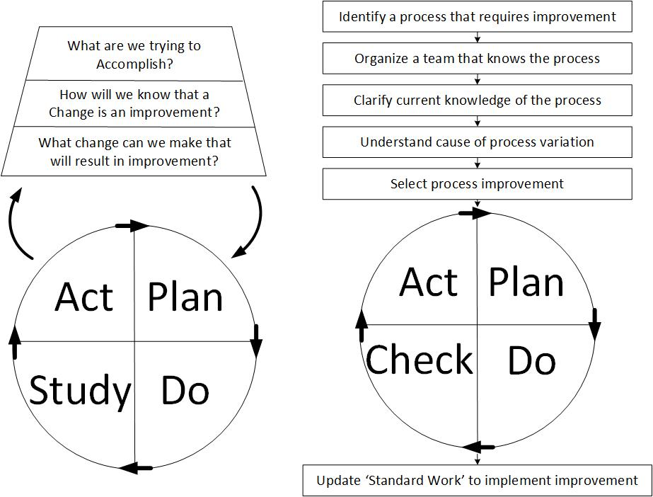

Figure 1, The PDSA Cycle compared with the PDCA Cycle
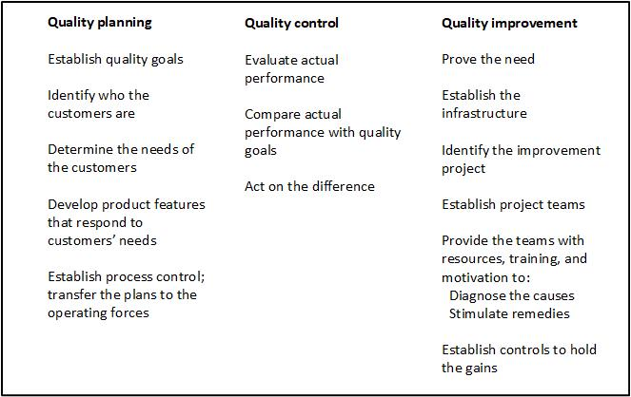
Figure 2, The Juran trilogy - The three universal processes of managing quality

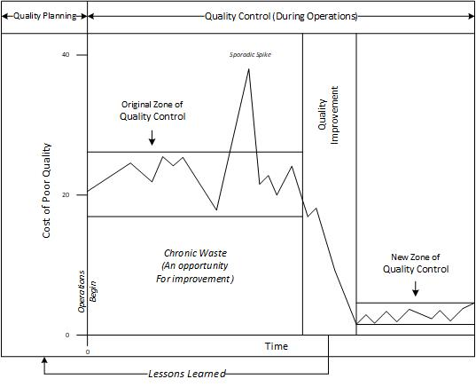
Figure 3, The Juran trilogy diagram

